CENTURA IP20 varianten:

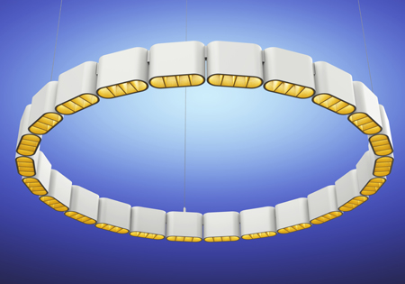
Centura 40. Ring. Downlight

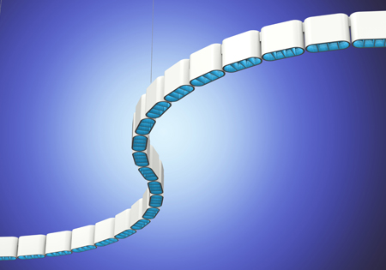
Centura 40. Flexible. Downlight

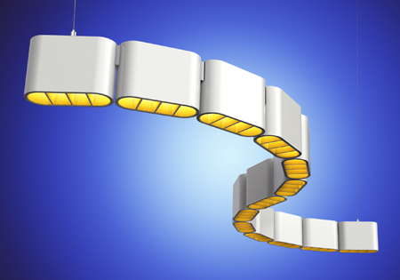
Centura 40. S-Curve. Downlight

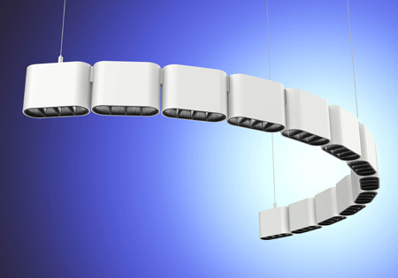
Centura 40. C-curve. Downlight

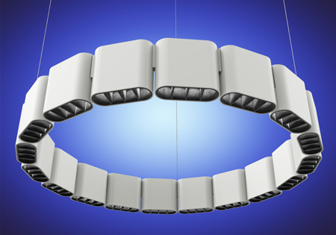
Centura 40. Ring. Up and Downlight

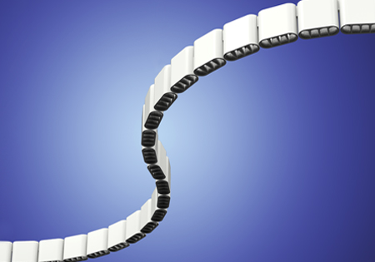
Centura 40. Flexible. Up and Downlight

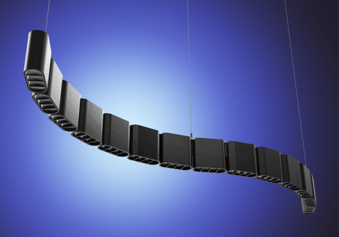
Centura 40. S-Curve. Up and Downlight

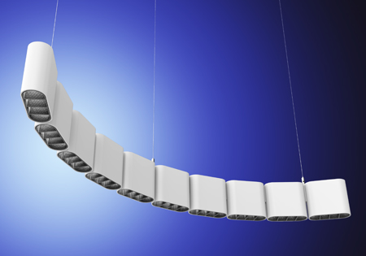
Centura 40. C-Curve. Up and Downlight

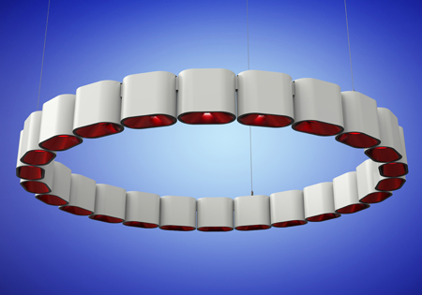
Centura 60 RGBW. Ring. Downlight

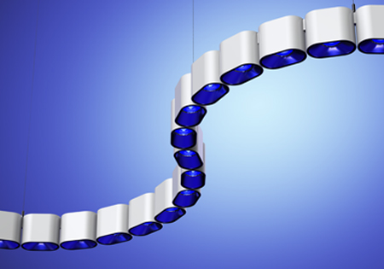
Centura 60 RGBW. Flexible. Downlight

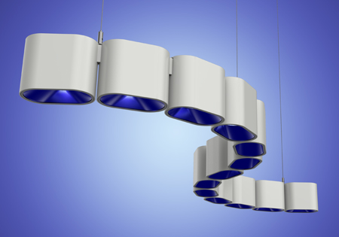
Centura 60 RGBW. S-curve. Downlight

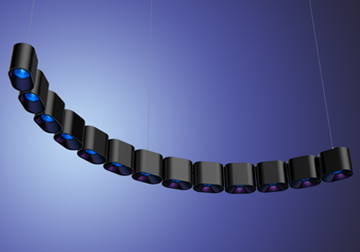
Centura 60 RGBW. C-curve. Downlight

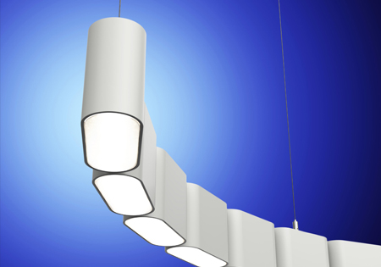
Centura 40. Diffuser. Flexible. Downlight

